Ololade Omosebi

List of suspects.

Jordan

Mikayla

Whitney

Kristin

Quentin

Holly

Brandon

Greg

List of people that have been cleared.

Xavier, Sean and Dante were in class the time of 2 thefts. On august 28th and October 9th. Luke was also in class at the time of the theft of October 5th at 3pm. Ursela was at the permit office at the time of the crime on 09/03. Riley and Cristian were at the white building at the time of the crime on Aug. 28th. Nicolas was at practice at the time of the thefts on Aug. 28th and Oct. 9th. Ariana was playing tennis with a friend on Oct. 9th during the time of the robbery. Frank was at home, during the time of the robbery. Yadir can’t be a suspect, he has been in D.C the entire time. He will be there for the entire semester. Vanessa is not a suspect, there is not enough evidence to prove that she is a part of this theft ring. Zahra is also not a suspect. Ariana is not a suspect; she wasn’t anywhere around the sites of the thefts. Tay is also not a suspect. Not enough evidence against him. Orin and Elizabeth are also not suspects. These people are not suspects because there is no evidence to suggest that they were present in all 4 locations of the previous crimes. We also have witnesses that saw most of them at the time of the crimes.

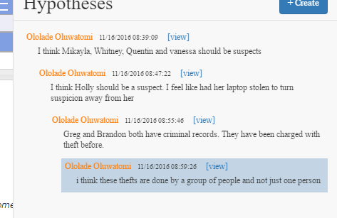

Above are some hypothesis, I thought about. From the evidence, it seems like everyone was away during at least one crime, which make me suggest that the crimes were being committed by a group of people and not one person.